GEORGE MULLER 1805-1898

KS2 UNIT 9 How should we live and who can inspire us?

Exploring positive examples of how to live, values and commitments of faith founders, how actions of people of faith have changed the world.

This example was written by Sue Thompson and Jane Gillis.

Local example from Bristol - GEORGE MULLER – He was a Christian and the founder of Muller orphanages in Bristol. He looked after over 10,000 orphans in his lifetime.

Resources available
- The Bristol Miracle booklet on the life and work of George Muller (suitable for supporting teachers) – pdf available
- Scanned records of orphans, including the first orphan – Charlotte Hill, birth certificates, death certificates, admissions and dismissals
- Scanned photographs
- Power point showing a visual chronological history of George Muller’s life
- Interactive timeline and videos http://www.mullers.org/timeline
- Worksheet for year 4-6 for use at the museum
- Volunteer available to visit schools and tell the George Muller story
- FREE Museum visit to 7 Cotham Park, Cotham, Bristol, BS6 6DA – interactive experience including a short talk, Question and Answer time, opportunities to explore artefacts. Book a visit by calling 0117 9245001 (Monday to Friday 10am-4pm) or fill in a contact form online www.mullers.org/school/visits
- Two options for teaching about George Muller including some ideas for activities – see below:

OPTION 1
Visit the museum for an interactive experience of George Muller’s life and work.

Follow up lesson about the life and work of George Muller – choose from some of the suggested activities below or use your own!

OPTION 2
One or two lessons focussing on the life and work of George Muller – choose from some of the suggested activities below or use your own.

Suggested activities

1. Starter activity whether you are visiting or not – Paint the scene of life for many poorer children in Victorian Bristol. The following websites might be helpful.
http://www.victorianchildren.org/victorian-children-in-victorian-times/
http://www.victorianweb.org/genre/childlit/childhood4.html

You could also use the following bullet points to paint the scene.
- Poor Victorian children lived in very small houses, or even in single rooms.
- Most of the children were sent out to work to earn money for the family.
- Some children were even sent out to work at the age of 4 or 5 years old.
- Some families had 10 or 12 children, so that they could earn more money.
- The children often worked in filthy, dangerous conditions. They worked long hours – sometimes up to 18 hours a day. They worked in mines, factories, textile mills, on farms, as servants in houses, as chimney sweeps, as clothing and hat makers etc. Their wages would have been very low.
- Many of the poorest children lived on the streets. They were either orphaned, or from neglectful families.
- There were a lot of children who were orphans in Bristol, due to the cholera epidemic.
- Some of the orphans were treated very badly.
- Some of the children living on the street were forced to steal and beg to support themselves.

How would you want to change things for these poorer children in Bristol? – give 5 ways.

Following this activity tell the pupils that we are going to learn about someone who did change things to make the lives of these poorer children better – George Muller.

2. Worksheet for use at the museum – see separate worksheet.

3. Ranking ladder – What do you think were the most significant events in George Muller’s life? Children to write down in order of importance the most significant events in George Muller’s life. You could set a limit of 5 or 8 most significant events.

Extension activity – justify your reasons – why have you decided that the top 2 are the most significant events?

4. Hot seat George Muller – teacher is George Muller – children ask questions.

5. Conscience alley – Split the class in half. Form two lines – each half facing the other. One side think of reasons to persuade George to take a certain course of action, and the other side think of opposing reasons to take another course of action. One child is George Muller, who walks between the opposing sides, listens to their persuasive arguments and then when he reaches the end of the line decides the course of action he will take. Examples for conscience alley could include:

- George is a teenager. One side argues for George to go out with them for the night and drink, gamble and steal. The other side persuades George to join them in a local house to pray and read the Bible.
- George is now 30 years old. He plans to set up his first orphan home with his wife. This will be in their own home and have room for 30 girls to live. One side argues for George to follow this plan, giving reasons about what God might think about this plan. The other side persuades George to think about having a nice home for him and his wife to enjoy with family and friends.

6. Questions for George Muller – in pairs, work out the top three questions that you would like to ask George. Join with another pair and look at each others questions. Decide together on your top two questions for George (narrowing down the questions, and deciding the most important ones you want to ask).

7. Prayer activity – Read the sheet with facts and stories about George Muller’s answers to prayer - see attached. Lead a discussion about prayer, answer questions like: Is prayer important – then and now? Does prayer work? Does this story inspire you to pray? Why? What things do you think it is important to pray about?

8. Write a newspaper report about the fifth Ashley Down Orphanage that is being built. Include information about the growth of the George Muller orphanages over time. Use the timeline on the Muller’s website to help.

9. Photograph activity – choose a selection of photos. Stick each one on a large sheet of paper and put them on separate tables. Ask the children to work in groups of 4, visit each photo and write around the photograph any questions they would like answered. Move around to the next photograph after a few minutes.

10. Write a thank you letter to George from one of the orphans (possible Homework activity)

11. What inspires you most from the life of George Muller? How could this make a difference to the way you live your life?

EXPLORE THE MUSEUM WITH A PARTNER

There are spaces for written answers but some questions are for discussion with your partner.

- Look at the timeline 1805-1895. When would you say the difficult times were for George Muller?

…..…………………………………………………………………………………………………

…..…………………………………………………………………………………………………

- Look around the museum and see how many items you can identify. Talk about them with your partner.

- Look at the embroidery that the girls created.

- Can you see a surprising task that the boys did? ……………………………………

- Look at the photographs. What sort of activities can you see the children doing?

…..…………………………………………………………………………………………

…..…………………………………………………………………………………………

- Are there are any photographs that you don’t understand? Ask an adult to explain what is happening.

Write down 2 facts that you didn’t know about George Muller before you visited the museum.

…..…………………………………………………………………………………………

…..…………………………………………………………………………………………

Look at George’s desk. We are told that he prayed with each orphan when they left the orphanage. Why do you think he did this?

…..…………………………………………………………………………………………

…..…………………………………………………………………………………………

- Do you have any further questions to ask our guide?

…..…………………………………………………………………………………………

…..…………………………………………………………………………………………

- Draw your favourite object and say what it was used for.

GEORGE MULLER’S LIFE OF PRAYER

- George Muller believed that God answered prayers. He prayed everyday for hours about many different things and expected his prayers to be answered by the amazing God that he believed in.
- George Muller didn’t get paid wages for what he did; he just trusted that gifts would be given to provide for his family. He knew God providing for his family all the way through his life.
- During his life time, Muller cared for over 10,000 orphans in Bristol. He never made appeals or asked for money, or did fundraising events, instead he trusted that God would provide what they needed, and he prayed for what they needed each day.
- In his life time, he received £1,500 000 – from gifts. This would be about £90,000,000 today.
- The first orphanage opened on 21st April 1836 in Wilson Street, St. Pauls. George Muller, had asked God for £1,000 and the right people to run the orphanage. Within five months all that they needed had been provided.
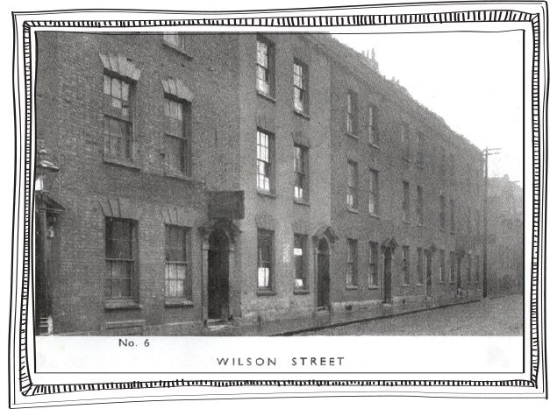
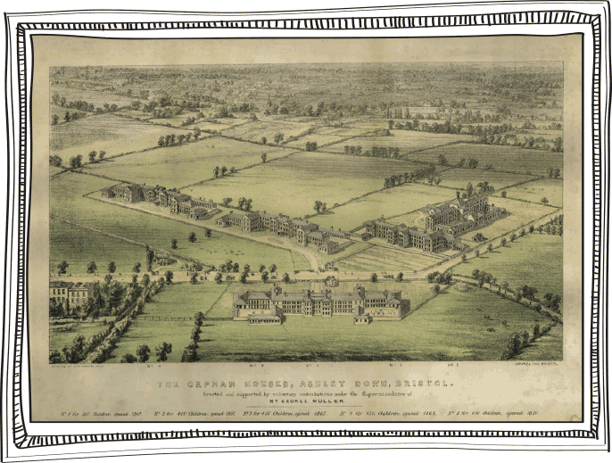

- A few years later, George had opened 5 new orphanages on land that he bought on a rural site at Ashley Down, just outside the city boundary.
- Some days, it was as if God literally provided for them from hour to hour. One day they had run out of food. 300 children sat waiting for their breakfast. George prayed to God and thanked God for the breakfast that they were about to eat, confident that God would provide food for them. There was a knock at the door and the baker was standing outside with a big load of bread. He said that God had woken him up in the night and told him to bake more bread than usual and to take it to the orphanage. George said thank you for the bread and took it inside for the children. There was another knock at the door, and this time it was the milk man. A wheel on his cart had broken outside the orphanage. He didn’t want to leave the cart and go and get what he needed to fix the cart, as he said the milk would get stolen. So he had decided to give the milk to George for the children instead! So breakfast was provided!
- Strong gales in Bristol on Saturday 14 January 1865 caused considerable damage in the area and over twenty holes were opened in the roofs of the orphanages. Around 20 windows were also broken and two frames damaged by falling slates. The glazier and slater, who were normally employed to fix things, had already committed their staff to other work so nothing could be done until the Monday. Had the winds continued, with heavy rain, the damage to the orphanage would have been much greater. George prayed for the weather to calm down. The wind stopped in the afternoon and no rain fell until Wednesday, by which time most of the damage had been repaired.
- Later on in life, George decided to travel around the world, telling people about his incredible God and what God could do when we trust and ask him. When he was crossing the Atlantic in 1877, his ship ran into thick fog. George explained to the captain that he needed to be in Quebec by the following afternoon, but the captain said he was slowing the ship down for safety. George asked the captain if he could use the chartroom to pray for the fog to lift. The captain followed him to the room, claiming that prayer would be a waste of time. Muller prayed, and then the captain decided to pray. Muller stopped him and said, the prayer had already been answered. They went upstairs to find that the fog had lifted. The captain became a Christian not long after.
- George Muller died a poor man in 1898. Bristol came to a halt when his funeral happened. Factories and businesses closed, and thousands of people came out to mourn and pay respect as the funeral procession went by. Below is a quote from the Bristol Times newspaper on the day of his funeral “he was raised up for the purpose of showing that the age of miracles is not past”.

