Awareness Mystery Value (AMV)
KS2 Unit 6: How do we make moral choices? [Areas of Enquiry A & F]
This unit explores how religious and other beliefs affect approaches to moral issues
About this example: This series of eight lessons is intended to provide a set of learning activities in RE for a Year 5 class. It was written by Sushma Sahajpal, with additional ideas by Anita Compton and Dave Francis.
The focus here is on developing and encouraging pupils to consider relevant moral issues in their own lives and possible consequences of certain actions. They will also explore Hindu and Christian codes of behaviour and compare and contrast, then make this relevant to their own experiences.
RE Skills covered in this unit: (main in bold)
1) Investigation (asking questions, gathering information); 2) Interpretation (suggest meaning from religious texts and other sources);
3) Reflection; 4) Empathy; 5) Evaluation; 6) Analysis; 7) Synthesis; 8) Application (religious values and link to secular values); 9) Expression (articulate values); 10) Self-understanding.
How this fits into the curriculum:
This example connects with AMV Areas of Enquiry A (Beliefs, teachings and sources) and F (Values and commitments). It makes cross-curricular links with Literacy, PSHE/SEAL, Drama and Art.
The lessons could be used in discrete RE time or as part of a ‘creative curriculum’ approach where RE links with other curriculum around a theme or key question e.g. ‘Our Community’, ‘Right and Wrong’, ‘Powerful Stories’.
Prior Learning:
When pupils reach Yr 5 it is hoped that they have a clear understanding of what it means to belong to a religion. It is also anticipated that they will have a basic knowledge of Christianity and three other main world religions (Judaism, Islam and Hinduism).
Featured Religions / Beliefs | Focus ‘Key Concepts’
Hinduism | AT 1: Learning ABOUT religion |  | AT 2: Learning FROM religion
Christianity | A. Beliefs, teachings and sources |  | D. Identity, diversity and belonging
 | B. Practices and ways of life |  | E. Meaning, purpose and truth
 | C. Forms of expressing meaning |  | F. Values and commitments

Key Question: How do we make moral choices?
Supplementary Questions
- What are moral questions?
- What are the consequences of the moral choices we make?
- What people and organisations help in making moral choices?
- What are the most important moral values and teachings?
- How do we decide what is right and wrong?
Resources:
Resource 1: Female Hindu Deities
Resource 2: Transcript of an interview with Leicester School Children talking about Navratri
Resource 3: Navratri Durga Story – Central importance of Durga to Navratri
Jay Lakhani of the Hindu Academy speaks on the deeper meaning of Navratri on You Tube: www.hinduacademy.org/videos/latest.php > scroll down to Navratri
Three female deities: www.hindufaqs.com/tridevi-the-three-supreme-goddess-in-hinduism/
Summary of deities: www.tes.com/teaching-resource/hindu-gods-and-goddesses-6345935
Navratri: www.bbc.co.uk/religion/religions/hinduism/holydays/navaratri.shtml

Expectations: Focus areas A and F.
By the end of this sequence of learning:
All Pupils:  Level 2 | Most Pupils (majority class expectation):  Level 3 | Some Pupils:  Level 4
A2 describe the three main Female Deities (Tridevi) featured in Navratri and say some things that Hindus believe. | A3 describe what a Hindu believer might learn from thinking about the Hindu Deities and beliefs about the Navratri festival. | A4 discuss links between the beliefs regarding important female figures in other religious groups such as Mary in Christianity and show how they are connected to believers’ lives.
F2 talk about what is important to them and to others with respect to what sort of people should have power and how people in power should treat others and whether their gender matters. | F3 link things that are important to them, e.g. the role of mothers, and Hindus, e.g. the role of the Divine Mother, with the way they think and behave towards mothers and also towards those with less power than them. | F4 ask questions about the moral decisions people make, and suggest what might happen as a result of different decisions, including those made with reference to the qualities of the Hindu deities.

These statements are taken from the old ‘Can-do’ levels. The new ‘Learning Outcomes’ can be found in the ‘Standards’ section of the new AMV website: http://awarenessmysteryvalue.org
Key Question: How do we make moral choices?
Supplementary Question: (d) What are the most important moral values and teachings?
Learning objectives | Suggested activities for teaching and learning | Outcomes | References and notes
Lesson 1  Pupils will:  - learn about the nature of God in Hinduism;  - reflect on the qualities of mothers. | 1. Explain that pupils are going to learn about the Festival of Navratri when Hindus celebrate the Divine Power they believe is available to all of us (not just Hindus) in whichever form is best for us, in the way a loving mother helps her children.  Explain that Hindus believe that God is neither male nor female but is everywhere in everything and everyone. Thus they believe God can intervene to support righteous living (meaning for universal good) at anytime in any form including as a man, woman, child, animal, river, etc. Explain the forms that are celebrated at Navratri are three Mothers.  Ask the pupils to think of words they may use to describe a mother. List these up on a board. Now ask them to think of activities/actions that they think mothers do. Again capture these on the board. Now ask the pupils to consider mothers from the animal kingdom (hunting, fighting off predators, etc.), does this bring forth any more adjectives or verbs? Ask pupils to get a good spread of words through as many different ‘forms’ of mothering as possible. Some words like ‘helper’ can be unpacked into types of help.  Ask the pupils to work in groups with three very large pieces of paper per group. Ask the groups to write ‘Provider’ in large letters in the middle of the first sheet, ‘Protector’ in the middle of the 2nd and ‘Teacher’ in the middle of the 3rd. Their task then is to write or draw around the key aspects the ideas, actions, tools and questions they associate with those roles. Encourage the pupils to consider the differences between the three aspects.  You may need a fourth sheet (Other) for characteristics that are either more human than divine such as ‘Cranky’ or ‘Bad-tempered’ or don’t fit into the archetypes. Reviewing the fourth sheets may offer up a potentially very useful broader discussion. | Pupils:  - talk about what is important to them and to others with respect. | Key vocabulary:  Navratri, divine, Hindu, ‘righteous living’, mother, deity.  Notes:  This series of lessons is intended to help pupils explore what people think about types of power in themselves and the world. Pupils will question what role gender plays and what power as a force for good might look like. For Hindus, the three female archetypes – linked to female deities) are:  - Provider – supplying material well-being and nourishment: Lakshmi;  - Protector/Powerhouse - fighting off predators / pure strength: Durga;  - Teacher – teaching / explaining / advising: Saraswati.
Key Question: How do we make moral choices?
Supplementary Questions: (c) What people and organisations help in making moral choices?
(d) What are the most important moral values and teachings?
Learning objectives | Suggested activities for teaching and learning | Outcomes | References and notes
Lesson 2  Pupils will:  - explore the symbolism and qualities of the three female Devis;  - learn about literal and metaphorical ways of looking at the Hindu deities. | 2. Ask the pupils to sit in pairs, with one of each pair sitting with their back to their partner. The pupil in front should have pencil and paper at the ready. Give one of the images of the three female deities (or ‘Devis’), Lakshmi, Saraswati and Durga, to each pupil sitting behind their partner and ask them to describe the deity in their picture to their partner, whose task is to draw what it described.  Ask them to compare their results with the originals and notice any differences. Explain that each picture represents a different form of Divine Mother and that Hindus believe that all the power needed to succeed comes to human beings through Divine Mothers providing the three lists of things already discussed, that is, Knowledge (Power of Understanding), Personal Strength (Raw Transformation Power) or Material Abundance (Power of Physical Well-Being).  Give the pupils a chance to examine carefully for themselves the symbols and colours of each picture and see if they can suggest which image goes with which of the archetypes they have defined.  Now go through each deity engaging the pupils’ questions and ideas about what each deity is sitting on, holding and wearing. Explain that it is possible to take these definitions literally, i.e., as supernatural beings that may manifest in the world, and also apply them metaphorically to our lives here and now, e.g., in wanting more of the resources the Mothers offer to be in our lives. Clarify, that just like a human mother, the Divine Mothers do not ‘take over’ and simply do things ‘for us’. Hindus believe that they assist us in finding the skills and strengths we need inside ourselves.  Put the Lists of words about mothers that the pupils have already compiled on the board below each Deity and ask them to add some more words to their sheets that they think Hindus would associate with each of the key aspects. | Pupils  - describe the three main Female Deities (Tridevi) featured in Navratri and say some things that Hindus believe;  - talk about what is important to them and to others with respect;  - describe what a Hindu believer might learn from thinking about the Hindu Deities. | Key vocabulary:  Devis, deities, divine mother, transformation, literal, metaphorical,  Notes:  See Resource 1 for pictures of the three Devis: Lakshmi, Saraswati and Durga.
Key Question: How do we make moral choices?
Supplementary Questions: (a) What are moral questions? (b) What are the consequences of the moral choices we make?
(e) How do we decide what is right and wrong?
Learning objectives | Suggested activities for teaching and learning | Outcomes | References and notes
Lesson 3  Pupils will:  - consider practical examples of when people might need wealth, wisdom or strength;  - reflect on why Hindus might pray to the Devis. | 3. Ask the pupils if they know what a moral dilemma is. [When you have to choose to do one of two things, each of which may have unpleasant consequences.] Give some examples and ask the pupils to work in pairs to come up with their own, e.g., they were given £5 but lost it on the way to school. At break time they see a £10 note caught in a hedge. What should they do? What might be the consequences of each decision?  Remind pupils of their work on the three Devis and ask them to describe some situations where might people feel the need for (a) well-being, (b) wisdom and (c) strength. Aim for concrete examples of each of these in their own lives and list them on the board. How many of these involve moral dilemmas? For example, when someone is poor or starving, how should they go about getting food? Should they steal to survive? When a friend does something bad to you, how should you respond? In a game where a person lacks the strength needed to win, should they break the rules to give themselves an advantage?  Ask the pupils to consider such dilemmas in relation to the Devis. Which one might Hindus pray to for help with each dilemma? Go through each ‘need’ and ask, How might a Hindu feel their prayers might be answered? Does strength have to be physical? Does physical well-being have to mean money? | Pupils  - describe what a believer might learn from thinking about the Hindu Deities;  - ask questions about the moral decisions people make, and suggest what might happen as a result of different decisions, including those made with reference to the qualities of the Hindu deities. | Key vocabulary:  moral dilemma, consequences, prayer, material and spiritual.  Notes:  Search for ‘Kohlberg’s moral dilemmas’ to find more examples of moral and ethical dilemmas.
Key Question: How do we make moral choices?
Supplementary Questions: (b) What are the consequences of the moral choices we make?
(c) What people and organisations help in making moral choices?
Learning objectives | Suggested activities for teaching and learning | Outcomes | References and notes
Lesson 4  Pupils will:  - consider why some people seek divine help for their problems;  - reflect on the differences between Hindu deities and Christian saints;  - explore different types of help and support that people need and can give. | 4. Explain that many followers of religions look for divine help in solving moral dilemmas. Sometimes the help looked for is set in male terms and sometimes female. In the Christian Bible, for example, God is often presented as a ‘Father’ figure (although there are some female metaphors) and that, for many Christians, prayer for help in times of trouble is often directed to holy people called ‘saints’ and there are many male and female saints. Ask pupils to consider how this may be different from how Hindus relate to the Devis. [Highlight how the female figures in Christian traditions are loving intercessors with God rather than God themselves.]  Ask pupils to list some words that a Christian might use to describe God as Father. What words might they use to describe Mary? Ask pupils to compare her qualities to the three Hindu Deities we have looked at [Highlight similarities, e.g., loved as a mother, as well as differences, e.g. ‘holy not divine’] and to say how they are each thought to make a difference to believers’ lives.  Invite pupils to link things that are important to them, e.g. who helps them, with the way we might offer to help other people, and different kinds of help; physical and mental / spiritual. Encourage them to think about who they might turn to in their own lives. What sort of skills would the person they turn to, need to help them and what form would that help take? How might they help someone who was confused, for example unable to do their homework? or had less money or was physically weaker and being bullied?  [This could be a very worthwhile drama lesson with some interesting role-play activities about what they feel is appropriate assistance / relationship with someone with less power / advantages than themselves.] | Pupils  - link things that are important to them, e.g. the role of mothers, and Hindus, e.g. the role of the Divine Mother, with the way they think and behave towards mothers and also towards those with less power than them;  - discuss links between the beliefs regarding important female figures in other religious groups such as Mary in Christianity and show how they are connected to believers’ lives. | Key vocabulary:  moral dilemma, consequences. saints, holy, intercessors, prayer, divine, spiritual.  Notes:  Christians do not say that the saints are divine or equal to God, but that they lived such good lives that they are very close to God. Saints are therefore believed to have power to ask God to help those who pray to them.  Many Christians in the Orthodox, Catholic and Anglican traditions pray to Mary, who, as the mother of Jesus (who is believed to be ‘God and man’), is in the best position to intercede with God to request his help.
Key Question: How do we make moral choices?
Supplementary Questions: (b) What are the consequences of the moral choices we make?
(c) What people and organisations help in making moral choices? (e) How do we decide what is right and wrong?
Learning objectives | Suggested activities for teaching and learning | Outcomes | References and notes
Lesson 5  Pupils will:  - reflect on how a religious festival can help people learn lessons in life;  - learn from the experiences of children who celebrate Navratri. | 5. Remind pupils that they are investigating moral dilemmas by looking at how Hindus and others reflect on the choices that are open to them.  By now the children should have a good understanding of the three Devis. Explain that Hindus remind themselves of this relationship with female divinity twice a year during Navratri and that they are going to find out about this festival and how may help Hindus ‘do the right thing’ and make good moral choices.  Read the transcript of the Leicester children talking about Navratri [See Resource 2 ] (Audio no longer available).  What questions would pupils like to ask if they could meet the children in this interview?  What answers do they think the children might give?  Explain that during Navratri many Hindus fast during the day and then feast and dance in the evening time on traditional festival food. During the fast Hindus only eat foods that can be eaten very simply and with minimal process such as fruit, nuts etc. This is to encourage them to take time out from focussing on their material appetites and wishes but instead to focus on their spiritual goals of personal discipline and following divine guidance.  Ask pupils to identify what it might be good for them to give up for a week even though they might find it difficult to (such as a television program or chocolate) and give reasons.  Consider asking them actually to try doing this for parts of the day (or a week!) and perhaps be sponsored for each day they succeed in doing so as a charity fundraiser.  Ask them to journal their thoughts and feelings if they do it or make up an imaginary journal of someone their age trying to do so.  Ask them to focus on moral dilemmas they may face during the fast and to consider some Hindu perspectives. | Pupils  - link things that are important to them, with the way they think and behave;  - ask questions about the moral decisions people make, and suggest what might happen as a result of different decisions, including those made with reference to the qualities of the Hindu deities. | Key vocabulary:  Navratri, fast, festival, self-discipline.  Notes:  Put the interview transcript up on the board for children to see.
Key Question: How do we make moral choices?
Supplementary Questions: (b) What are the consequences of the moral choices we make? (c) What people and organisations help in making moral choices? (d) What are the most important moral values and teachings? (e) How do we decide what is right and wrong?
Learning objectives | Suggested activities for teaching and learning | Outcomes | References and notes
Lesson 6  Pupils will:  - learn about the Hindu festival of Navratri;  - consider female images in religious belief;  - consider traditional male and female roles in a family;  - begin to explore the symbolism of Hindu deities. | 6. Explain that once the fasting days and dancing nights are completed (this varies across regions and families, but typically on the 8th or 9th day), a special feast is prepared and offered to young girls. This is to celebrate and reflect on the Divine Contribution of females in families as Mothers, Sisters and Daughters, Creators of Life, Bringers of Love and Good fortune into men’s lives. The nine nights are dedicated as three nights for each of the three divine forms. Thus femaleness has a very special place in Hindu Spiritual life. Can the pupils think of other religions that have special female images [e.g., Christian Saints, Mary, Mother of Jesus, etc]; Are there any powerful females that you look up to or turn to in times of trouble? Why might it be important for some people to turn to women for help?  Ask pupils whether Hindus would traditionally think men or women are more powerful in the family? [No right or wrong answer to this – just a discussion point about who if anyone, might be ‘in charge’?] Who has most ‘say’ in the home? What do the pupils think themselves? Does it matter if it’s Father or Mother? Ask pupils to give reasons for their answers and compare across the class.  Provide pupils with a printed version of the Deities [Resource 1] and ask them to work in pairs / small groups to recall aspects of each Deity, labelling the different items with key points about what Hindus believe is being illustrated / symbolised.  Encourage pupils to discuss the details of the pictures in their pairs / groups and then to share ideas on the most important aspects for them. Prompt their thinking by asking whether they can tell which figure represents what sort of Divine Maternal help and whether they can work out why each Hindu Deity is sitting on such a different symbol?  Ask pupils to then add their own labels saying what they think is good about each of the Female Deities symbolic gifts, e.g. ‘The lute plays music’, ‘The sword is powerful’, ‘The book is for wisdom’. Provide pupils with some of these words to help them. | Pupils:  - talk about what is important to them and to others with respect to what sort of people should have power and how people in power should treat others and whether their gender matters;  - link things that are important to them and other people with the way they think and behave;  - describe the Tridevi featured in Navratri and say some things that people believe;  - talk about what is important to them and to others with respect for their feelings. | Key vocabulary:  Devis, deities, divine mother, transformation, literal, metaphorical, symbolism.  Notes:  The symbolism of Hindu deities goes deeper than might be suggested here; the idea is to start pupils thinking about how worshipping the different Female Deities helps believers in a variety of ways.
Key Question: How do we make moral choices?
Supplementary Questions: (b) What are the consequences of the moral choices we make? (c) What people and organisations help in making moral choices? (d) What are the most important moral values and teachings? (e) How do we decide what is right and wrong?
Learning objectives | Suggested activities for teaching and learning | Outcomes | References and notes
Lesson 7  Pupils will:  - explore further the meaning of the female Hindu deities;  - consider how the practical value of the characteristics of the Hindu deities might be seen. | 7. Now divide the class into three groups. Assign a deity to each group. Ask each group to note what form of ‘Blessing’ their Female Deity represents (Protection / Strength, Provider / Well-being, Wisdom / Understanding). Ask pupils to imagine three (or more) situations that a child or adult might find themselves in when being blessed by their Deity would help. Have one example prepared for each Deity in case they get stuck! Pupils can work out their ideas in smaller groups, type them up on a computer as three separate sheets, then compare across the group. Ensure that the deity’s name is NOT on any of the papers! Collect in all nine situation sheets, shuffle them up and number them 1 to 9. Hang onto these for the next activity (below).  Explain that you would now like them to work out the role and meaning of the Female Deities in a range of situations. Divide the class into nine groups. Provide each group with one situation sheet made earlier. Ask each group to read the situation and to record their answer of which Deity’s power would be most helpful on a piece of paper next to each Situation number – give each group just 3 or 4 minutes for each situation. They then pass their situation on to the next group and so on till all groups have considered all the situations. This might be easier to share electronically so pupils can all consider all the situations at their own pace in pairs on computers. Share and discuss the answers across the class. What advice might pupils give if they were being appealed to for advice about these situations? | Pupils:  - describe what a Hindu believer might learn from thinking about the Hindu Deities. | Key vocabulary:  Deity, qualities, characteristics.  Notes:

Key Question: How do we make moral choices?
Supplementary Questions: (c) What people and organisations help in making moral choices? (d) What are the most important moral values and teachings? (e) How do we decide what is right and wrong?
Learning objectives | Suggested activities for teaching and learning | Outcomes | References and notes
Lesson 8  Pupils will:  - learn about the story at the heart of the Navratri festival;  - write their own metaphorical stories;  - learn the Dandiya or Garba dances;  - know that the dances are symbolic of the Durga story told in some Hindu communities at Navratri. | 8. Tell pupils the story of how Durga vanquished the Demon that is the central story of Navratri.  Deepen their understanding with questions such as: Where did the Demon’s power come from? [Divine blessing of Brahma.] Why Brahma? [Ability to Create form.] Why did Divine power have to destroy him? [He misused the divine gift for personal greed instead of using it for righteous living.]  Ask pupils to write their own ‘metaphorical’ story with a character needing to call upon each of the three Deities turn by turn to help him or her through the challenges within the story. The challenges need to be such that each needs the particular blessing of each Deity to overcome the problem. The story should include questions that the main character asks about their dilemmas and how what the consequences might be of following or ignoring the help of the Deities.  If possible, learning the Dandiya or Garba dances that are traditional and specific to this festival are great fun and reinforce some key concepts of this learning. Firstly regarding the Hindu idea of time (and therefore everything, is cyclical and rhythmic) with the Divine Mother as a central unchanging constant in the centre of the dancing circle.  Secondly the Dandiya (stick dance) is a representation of the nine day Dual that Durga fought with the Demon and triumphantly won (symbolising how her divine power crushes the enemies of ignorance and personal ambition). | Pupils  - describe what a Hindu believer might learn from the story of Durga vanquishing the demon;  - ask questions about the moral decisions people make, and suggest what might happen as a result of different decisions, including those made with reference to the qualities of the Hindu deities. | Key vocabulary:  Devis, deities, divine  Notes:  Resource 3: Navratri Durga Story  BBC Newsround: ‘What is Navratri all about?’ shows some still pictures of Hindus celebrating Navratri with the traditional dances and talking about the cultural aspect of the festival.  Dandiya & Garba dance demonstration  Easy steps for beginners on YouTube.

RECORD OF ATTAINMENT
KS2 Unit 6: How do we make moral choices? (A&F) Year 5
All Pupils:  (Level 2) | Most Pupils - majority class expectation:  (Level 3) | Some Pupils:  (Level 4)
A2 describe the three main Female Deities (Tridevi) featured in Navratri and say some things that Hindus believe | A3 describe what a Hindu believer might learn from thinking about the Hindu Deities and beliefs about the Navratri festival. | A4 discuss links between the beliefs regarding important female figures in other religious groups such as Mary in Christianity and show how they are connected to believers’ lives.
F2 talk about what is important to them and to others with respect to what sort of people should have power and how people in power should treat others and whether their gender matters. | F3 link things that are important to them, e.g. the role of mothers, and Hindus, e.g. the role of the Divine Mother, with the way they think and behave towards mothers and also towards those with less power than them. | F4 ask questions about the moral decisions people make, and suggest what might happen as a result of different decisions, including those made with reference to the qualities of the Hindu deities.

Resource 1: Female Hindu Deities

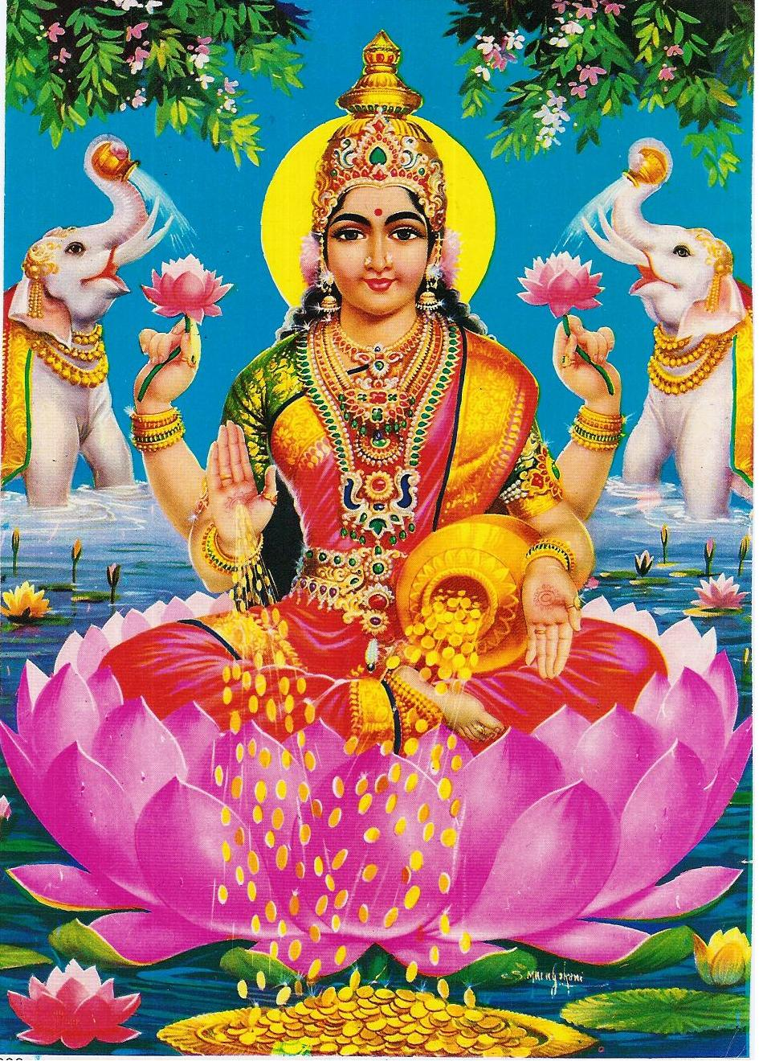
Lakshmi

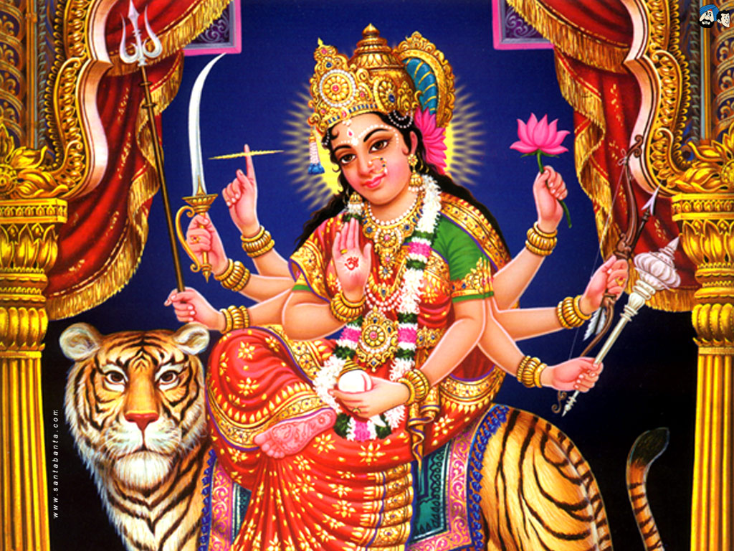
Durga

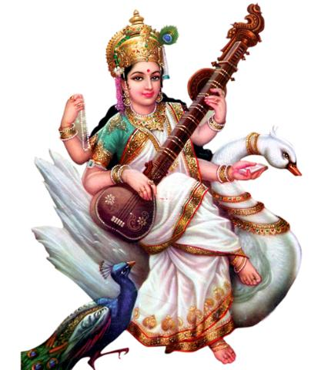
Saraswati
Resource 2: Audio: Leicester School children talk about Navratri
BBC Text Intro:
“A group of children from Abbey Primary School in Leicester explain what the Hindu festival of Navratri is about. They begin by explaining why the festival is celebrated and why Hindus pray to certain Gods during the nine days. They also talk about what the 10th day, which ends the festival, represents.”
Transcript:
“My name is Krishan. On 1 to 3 days of Navratri we pray to the Goddess Durga and She helps to remove ‘Unkindness’ in us. Navratri means: ‘Nav’ means Nine and ‘Ratri’ means nights.”
“My name is ... 3 to 6 Days of Navratri we pray to the Goddess Lakshmi who helps us find Good Health, Wealth & Happiness.”
“My name is Nyati. Six to Nine days of Navratri we pray to the Goddess Saraswati to give us Knowledge and help us to be thoughtful. We enjoy this time of year as we get to dance every afternoon in the school.”
“My name is Janaki and in Navratri people go to the temple with decorated Aarti plates. Inside it’s decorated with different materials including rice and beans.”
“My name is Vivi. In Navratri people go to shops and buy sweets. These sweets are given to God as an offering. After that they give the sweets to other people.”
“My name is Shruti. In Navratri ladies wear Saris. Children wear Chaniya Choli. They even wear Bindis and jewellery. Men wear Churida.”
“My name is Divanki and we like doing Mehndi [Henna] on our hands.”
“My name is Nyati. The eighth day is Ashthmi and it is very important. Girls are invited to people’s houses as they represent Goddesses. This is called ‘Goyani’ [in Gujerat or ‘Kanjak’ in Punjab]. Food is served and gifts are given to them.”
“My name is Dileesha. After the ninth day, is the 10th day called Dussehra which marks the victory of Good over Evil and also the ‘Motherhood’ of God.”
All: “The most important thing about Navratri is the dancing – hurray!!”
End.
Resource 3: Central Importance of Durga to Navratri
At Navratri, all the Goddesses are worshipped, with Durga being worshipped for the first three nights. Some Hindus give Durga special importance for the entire nine nights because of the story of her destroying the demon Mahishasura and his army to protect heaven. The story is a symbol of her power to destroy the bad within each of us, and her encouragement to us all to stand up for what is right.
Durga defeats the Demon: Mahishasura (Retelling of Ancient Puranic Scripture by Sushma Sajhajpal)
There was once a mighty shape-shifting demon called Mahishasura. He could take on many forms including animals. This was not enough for Mahishasura. He wanted to be the strongest and most feared of all the demons, so he pretended to be the God’s most dedicated worshipper. He prayed day and night, he fasted, he did yoga, he went on pilgrimages to holy places – anything to show Brahma how devoted he was. Finally, Brahma appeared and asked what he wanted. “I want to be invincible! So no man will be able to harm me.” Brahma granted his wish.
Mahishasura immediately gave up his life of devotion to Brahma. He set about capturing the towns and cities of India. Brahma’s gift kept him safe, no matter how violent and bloody the battle, Mahishasura always emerged from it completely unscathed. Stories were told of the mighty demon that no man could defeat, and so more and more demons joined his army until the empire of Mahishasura spread across the whole Earth.
But that still wasn’t enough for Mahishasura, and he decided to lead his demon forces against Heaven itself. The Gods were taken completely by surprise and were no match for Mahishasura. They re-grouped in the mountains and consulted with the three High Gods: Brahma the Creator, Vishnu the Sustainer and Shiva the Regenerator.
They discussed the problem of how to defeat a demon whom Brahma had stated that no man could harm. Brahma, Vishnu and Shiva combined their energies (Shakti) and from that explosion emerged Durga, the Warrior Goddess. She was beautiful and awesomely powerful. She had ten arms and held ten weapons, among them Vishnu’s mace and discus, Shiva’s trident, Indra’s thunderbolts, Vayu’s bow and arrows, Viswakarma’s axe and Agni’s fire. Finally, Himalaya gave her a magnificent lion to ride on.
So Durga sat gracefully on her lion’s back and led her army to meet the demon forces of Mahishasura. When the demon king saw her he laughed. “I’ll crush you without breaking into a sweat.” Durga listened to the demon bragging and laughed so loudly that it caused the Earth to tremble. The battle was long and bloody, and Durga was right in the midst of it, her weapons a steely blur as she dealt death to the demons all around her. After several days of carnage, the forces of good were finally fighting back the forces of evil, but Mahishasura sent Raktabija onto the battlefield. Each time a drop of his blood was spilled, another Raktabija sprang from the ground and soon there was a whole army of clones driving back and destroying Durga’s army.
Durga saw what was happening and closed her eyes and frowned in deep concentration. Suddenly she began to transform. Her skin darkened, her teeth grew longer and sharper and her muscles grew larger and firmer. She changed to her even fiercer form, Kali. She fell upon Raktabija and holding him tightly, bit deeply into his neck, draining him of blood. When his dead body slumped to the ground not a drop of blood was spilled to form new clones. Kali’s powers grew with the demon blood coursing through her veins and with lightning speed she ran across the battlefield, felling demons all around her, and whenever she found one of Raktabija’s brood, she drank its blood. She grew stronger and stronger and fought harder and harder until the whole demon army lay dead at her feet. She danced with victory.
As the blood cooled in her veins, she transformed back into the graceful Durga. She climbed onto her lion’s back and surveyed the battlefield. Only Mahishasura remained. Furiously he shape-shifted into a buffalo and charged towards Durga. As it thundered past, Durga plunged her sword deeply into the thick hide. The buffalo shape-shifted into an elephant which grabbed her lion. She hacked at the elephant’s trunk with an axe until it released her lion. The elephant staggered away, badly injured, but the demon still had enough power to shape-shift and became another lion. The two big cats reared up to fight with teeth and claws, but Durga’s mount was far stronger. Mahishasura shape-shifted back into human form and faced Durga, brandishing a huge sword. Durga laughed and advanced with her ten weapons held high. Mahishasura panicked. He had no chance against Durga in his human shape, so began to shift back into a buffalo. He was only halfway through the transformation when Durga leapt on him, pinning him down with her trident. With one stroke, she cut off the creature’s head. After nine long days, the battle was over and Mahishasura reign of terror was at an end. Good had finally defeated evil.

[Note: In the ancient Sanskrit text there are detailed descriptions of the many forms the demon took and the 9 forms Durga manifested to dual with him. In this story, we only cover one, Kali by way of illustration].
Image of Durga from Jai Maa Durga, Dreamland, New Delhi can be found at http://www.womeninworldhistory.com/lesson11.html

